**Test Plan**

Test Plan is a detailed document prepared at the project level. In general it defines work products to be tested ,how they will be tested and test type distribution among testers.

It is fully monitored and controlled by the testing manager. The test plan is prepared by the Test Lead (60%), Test Manager(20%), and by the test engineer(20%).

The test plan usually includes the following information:

1. The overall objective of the testing effort.

2. A detailed outline of how testing will be conducted (the test approach).

3. The features, applications, or components to be tested.

4. Detailed scheduling and resource allocation plans for testers and developers throughout all stages of testing.

Types of Test Plan

There are three types of the test plan

Master Test Plan

Phase Test Plan

Testing Type Specific Test Plans

Master Test Plan

Master Test Plan is a type of test plan that has multiple levels of testing. It includes a complete test strategy.

Phase Test Plan

A phase test plan is a type of test plan that addresses any one phase of the testing strategy. For example, a list of tools, a list of test cases, etc.

Specific Test Plans

Specific test plan designed for major types of testing like security testing, load testing, performance testing, etc. In other words, a specific test plan designed for non-functional testing

**Test cases**

What is a test case?

A test case is documentation created by the software tester that contains detailed information on what the test should accomplish.

It’s an essential part of recording information about testing activities and results.

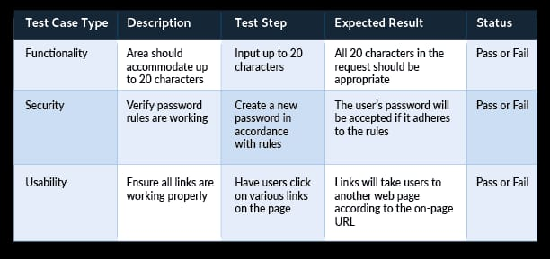

**Verification**

Verification involves the review of documents, design, and code to verify that all the project requirements are met.

Another way to define verification is as the process of checking that the result of a development phase meets the requirements set at the start of that phase.

**Validation**

Validation is the practice of studying and verifying the specific requirements of a particular stage in development. (on day to day basics , check if the flow is correct or not)